24 Port 1U Rackmount CAT5E UTP Patch Panel (PPAN-24-LC2)
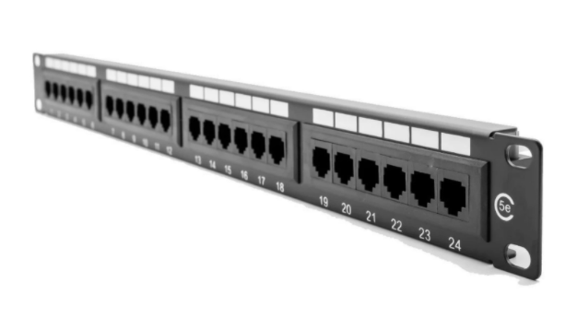

Description:
The LMS Data PPAN-24-LC2 is 24 Port certified CAT5e UTP Patch Panel which is ideal for structured cabling installations in offices of all sizes. Slim line, 1U height means its ideal for small wall cabinets as well as regular, floor standing cabinets and racks.
Fully Gigabit Ethernet certified means its ideal for running legacy and advanced networking protocols to Gigabit Switches up up to 1000Mbps. Also ideal for telecom, VoIP, CCTV-IP and other Ethernet based standards.
Long-life, nickel plated female RJ45s, robust construction with colour-coded rear Krone(tm) KATT type IDC for both TIA-568A/B terminations.
Need a robust but cost-effective regular Category5e Patch Panel for your business or telco application? The updated LMS Data PPAN-24-LC2 is a performance, fully gigabit compliant rear IDC punchdown patch panel for installations of all sizes and port counts. Ideal for current and future networking applications including Multimedia VoIP, converged IP and other LAN duties. 1U standard hight, robust alloy construction with port numbering and bespoke port ID’ing if required. Standard KATT (Krone) rear IDC and colour coding for EIA-568A/B termination. High integrity RJ45 ports with nickel plated connections to assure good conductivity, even after multiple cable insertions.

Key Features:
- Certified CAT5E Performance for Gigabit Ethernet
- Popular Krone(tm) KATT Dual Purpose IDC Punchdown
- 1u High means it fits in the smallest of data cabinets
- Part of the Synthesis 25-Year Warranty Solution

Specifications
- 24-Port UTP RJ45 Patch Panel - 1U height design
- Exceeds gigabit compliance for faster data speeds
- Exceeds current category 5e performance
- TIA-EIA-568A or TIA-EIA568B colour coded terminations
- Phosphor bronze and Nickel IDC connectors
- Supports 22 to 26 AWG conductor diameters
- Port identification and labelling facility
- Bundled cage nuts for cabinet attachment

Applications:
- Office, Education and Home Structured Cabling Installs
- Ideal for Gigabit Ethernet (1000Mbps) Data Networks
- Create fault tolerant LANs by simply patching ports

Product Code:
- Part Number: PPAN-24-LC2
- EAN: 8400800013231
- Weight: 0.5Kg approx.

Technical Specifications:
- Port Count：24 Ports UTP
- Dimensions： 1U 19-Inch Design Format
- Conformance： TIA-EIA-568A/568-B Coded IDC
- Performance：10/100/1000Mbps Gigabit Compliance
- RJ45/IDC Connects：Nickel and Phosphor Bronze
- Port Identification： Numbered and Bespoke ID Marker
- Fixings：Supplied M6 Nuts and Bolts
* Specifications and product design are subject to change. E&OE.

